Final Defense

Schedule for the Final Presentation is on December 16,2015 Wednesday

Panelist:

Sir.Alfred Calimbo Sir.Heintjie Vicente

Client: Max Restaurant Magallanes Makati City

[[edit](http://projects2.apc.edu.ph/wiki/index.php?title=Food_Trip_Search_Engine&action=edit&section=2)]

Project Title

FoodTrip Restaurant Search Engine



Project Authors

|  |  |  |
| --- | --- | --- |
| **Name** | **Position** | **Email** |
| Mr. Manuel "Sean" Sebastian Sanchez | Professor | manuels@apc.edu.ph |

**Project Adviser**

|  |  |  |
| --- | --- | --- |
| **Name** | **Position** | **Email** |
| Ernesto Boydon | Project Advisor |  |

**Project Team**

|  |  |  |
| --- | --- | --- |
| **Name** | **Position** | **Email** |
| Jimmy Tan | Project Leader | iftan@student.apc.edu.ph |
| Rouzandra Zuniga | Project Developer % Designer | rbzuniga@student.apc.edu.ph |

General Objectives

The General Objective of this Application Project is to provide Diner/User's to access location and information about the restaurant around metro manila.

Specific Objectives

• To provide hassle free restaurant search around Metro Manila.

• To find desired restaurants the Diner/User wants to visit.

• To show updated restaurant menu and promotions offered by the restaurant's.

Target Audience

• Guest

• Restaurant Establishment

• Diner/User

• Traveler

Cite Related Architecture

• zomato

• Android and IOS Appications

• Openrice

• munchpunch

Project Description

FoodTrip Restaurant Search Engine is an Application where you can easily access restaurant around Metro Manila explore high class restaurant's in different cuisine category and choose a restaurant you want to visit where you can view information,feedback and promotion deals.

Glossary

• **Android** - an open-source operating system used for smartphones and tablet computers

• **Diner** - a person who wants to dine, typically a customer in a restaurant.

• **Restaurant Establishment** - is an operation that stores, prepares, packages, serves, vends, or otherwise provides food for human consumption

• **Information Systems** - Information systems is defined as the process of and tools for storing, managing, using and gathering of data and communications in an organization. An example of information systems are tools for sending out communications and storing files in a business.

• **Feedback** - information about reactions to a food quality, a restaurant service performance of a task, etc., used as a basis for improvement.

Project Plan

**Event Table**

**Event Table For User**

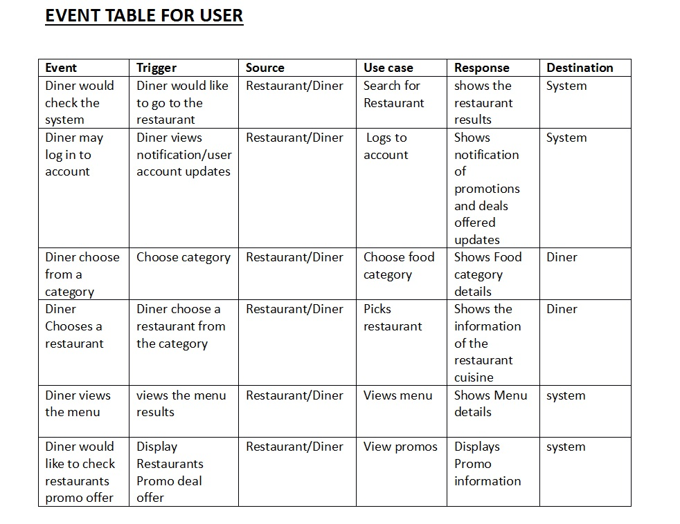

**Event Table For System**

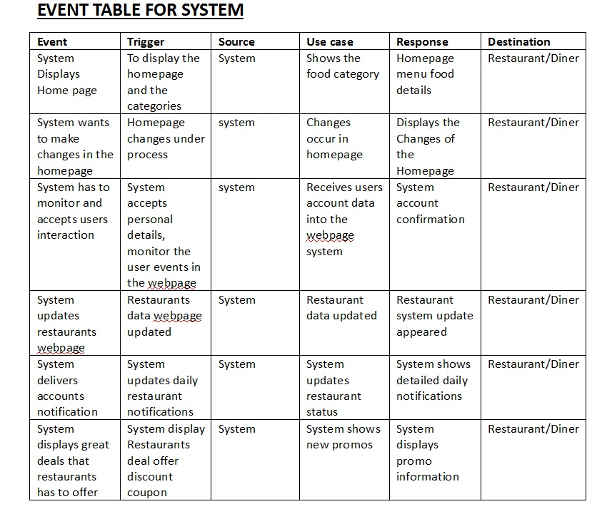

**Use Case Diagram**

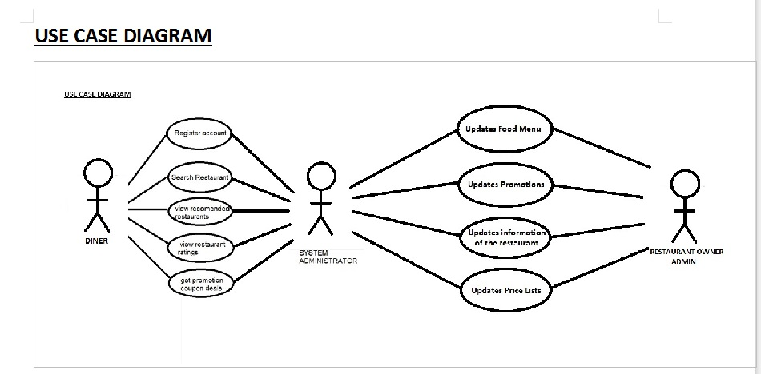

**Use Case Description**

**Food Trip Restaurant Search Engine Event Table**

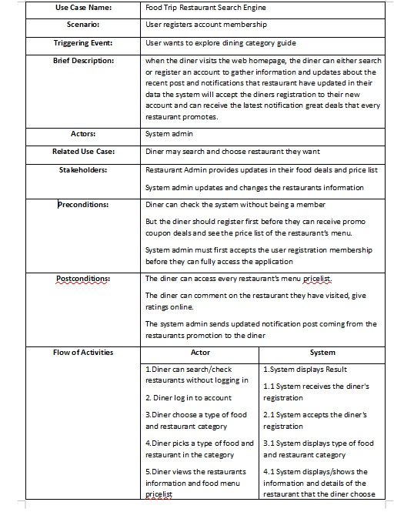

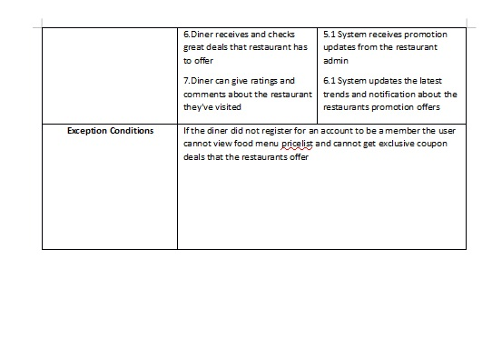

**Context Diagram**

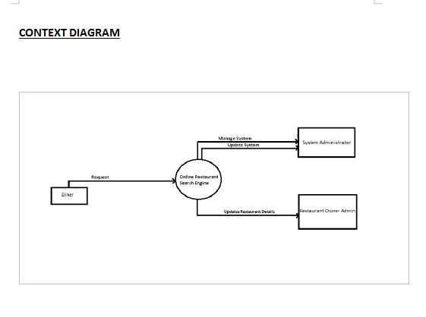

**Data Flow Diagram**

**Diagram 0**

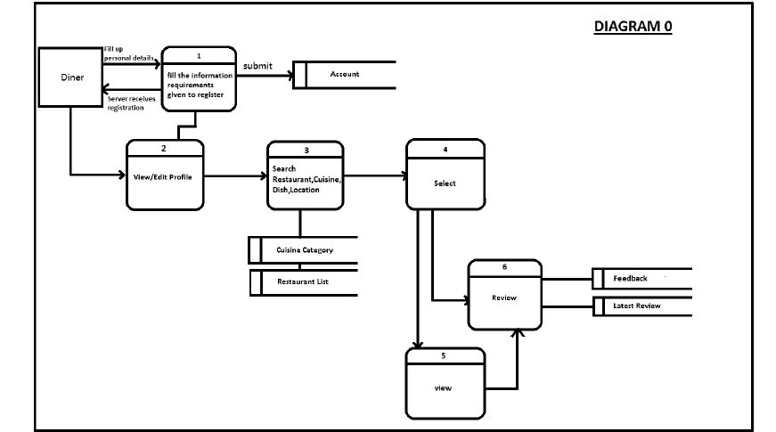

**Diagram 1**

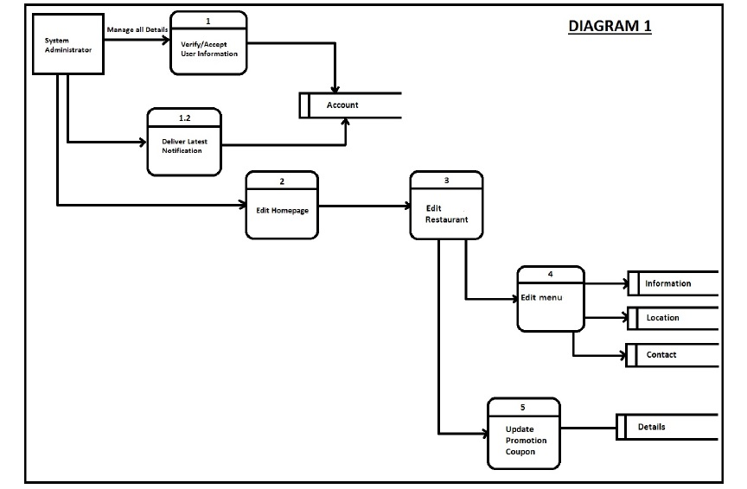

**Data Flow Diagram**

**Diagram 2**

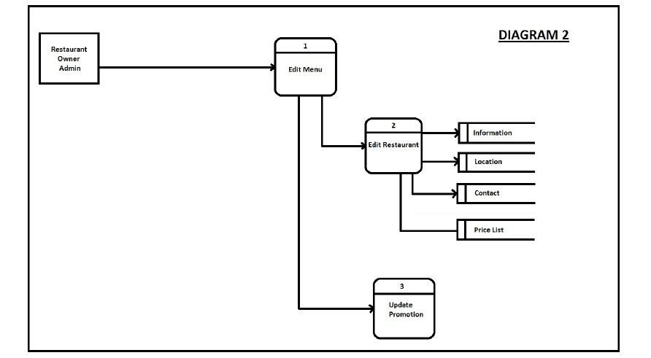

**Entity Relationships Diagram**

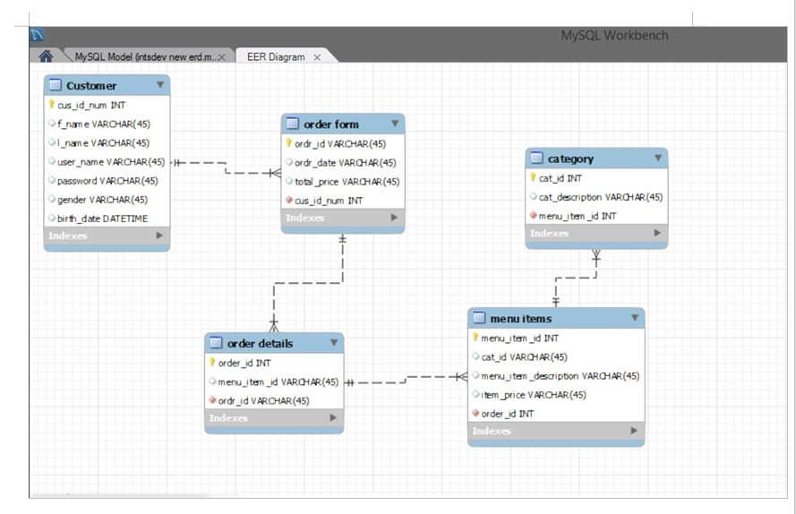

**Activity Diagram**

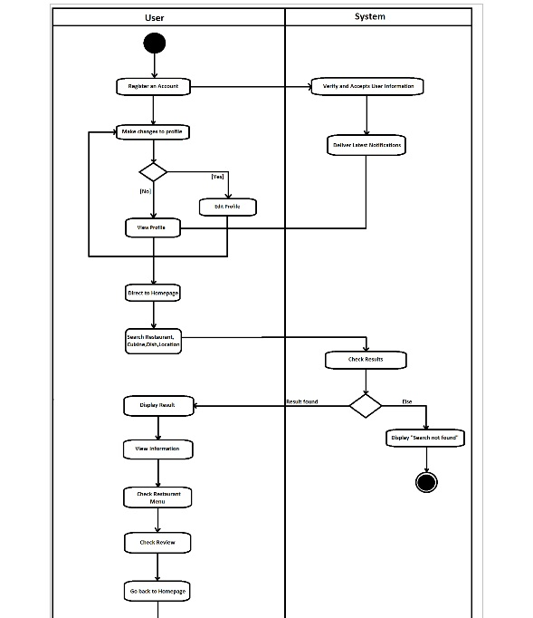

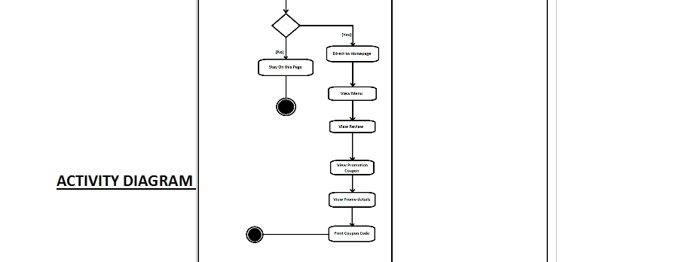

**Data Dictionary**

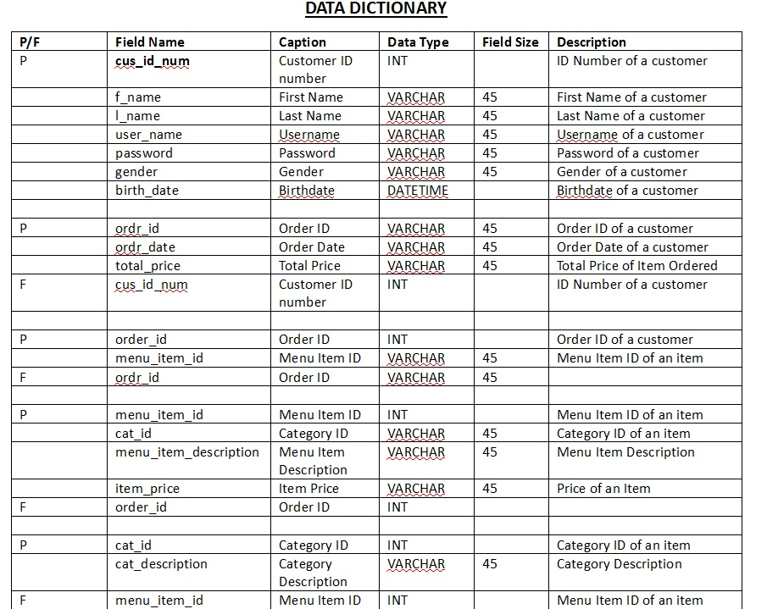

**Softcopies of Signed Status Reports**

**Gantt Chart/WBS/Activity List**

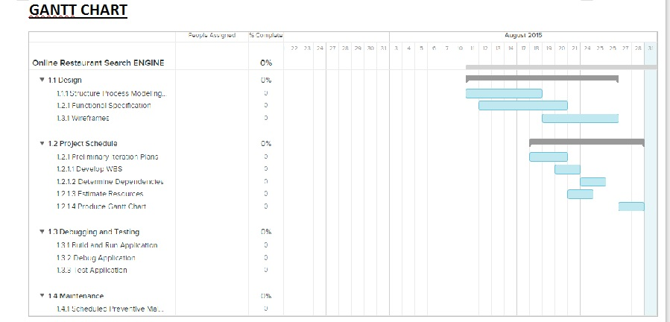

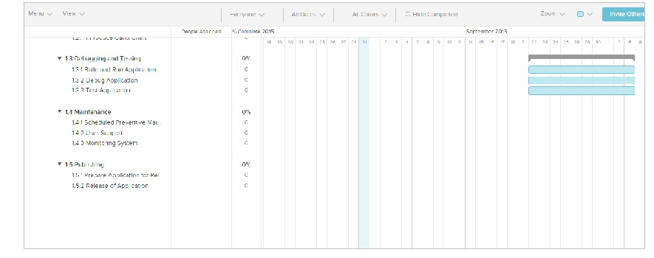

**WBS**

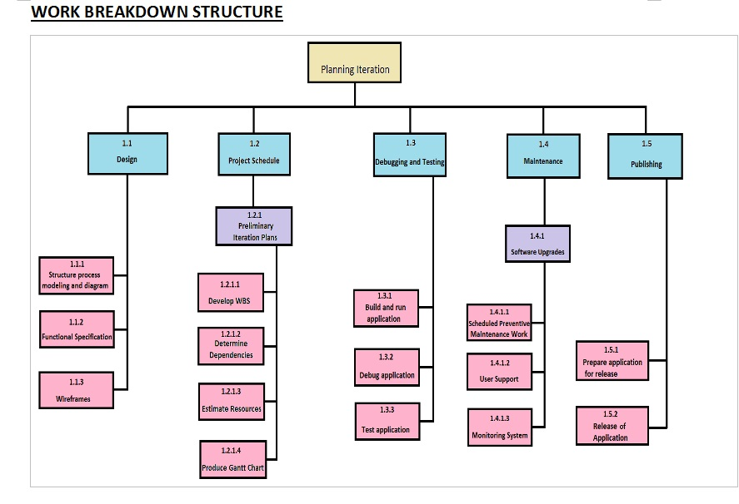

**Screenshots of Proposed System**

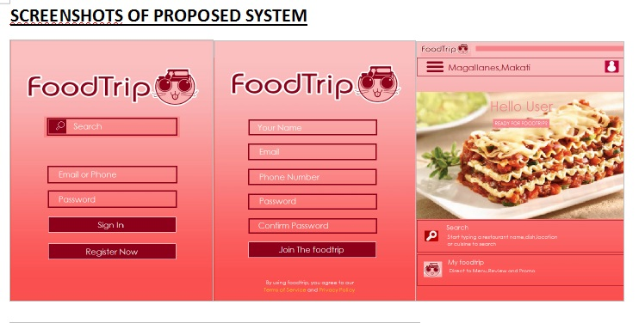

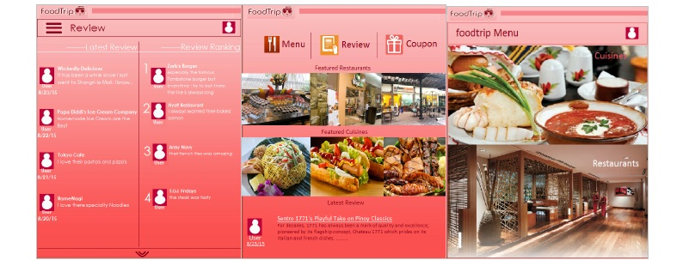

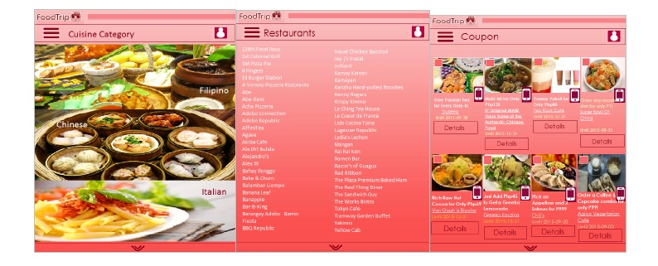

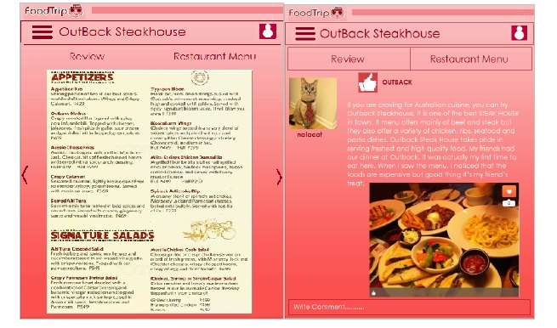

Project Title

FoodTrip Restaurant Search Engine (SYSADD1)



Project Authors

|  |  |  |
| --- | --- | --- |
| **Name** | **Position** | **Email** |
| Mr. Manuel "Sean" Sebastian Sanchez | Professor | manuels@apc.edu.ph |

**Project Adviser**

**Project Team**

|  |  |  |
| --- | --- | --- |
| **Name** | **Position** | **Email** |
| Jimmy Tan | Project Leader | iftan@student.apc.edu.ph |
| Rouzandra Zuniga | Project Developer % Designer | rbzuniga@student.apc.edu.ph |
| Jason E. Juarez | Project Developer | jejuarez@student.apc.edu.ph |

**Class Diagram**

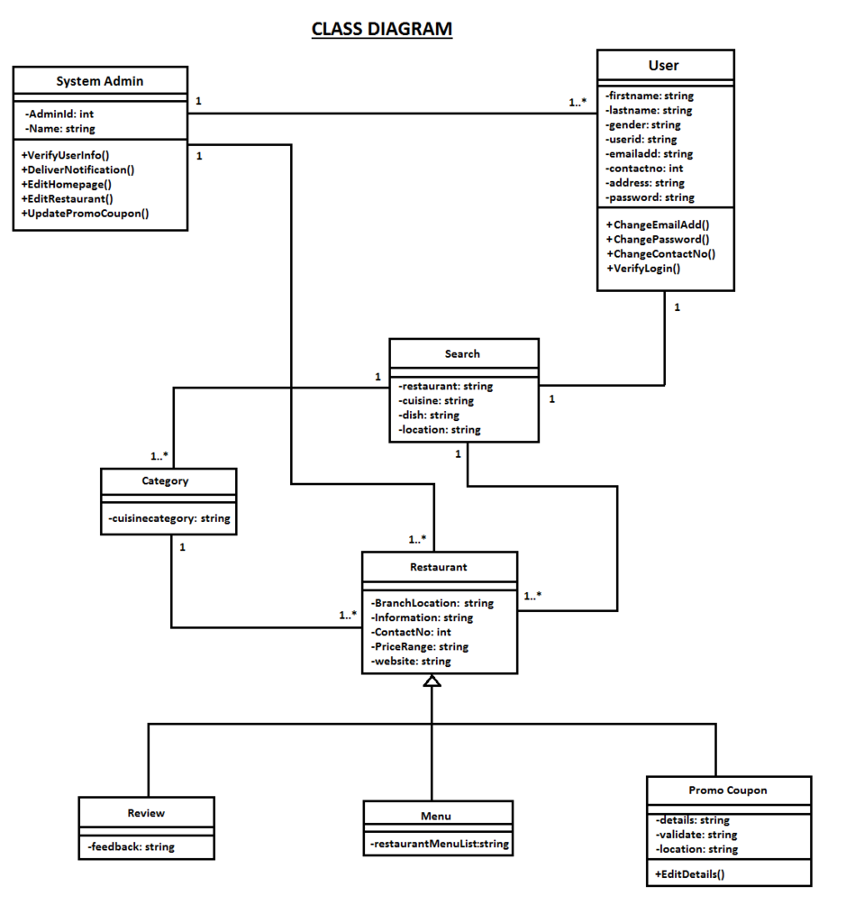

**Object Diagram**

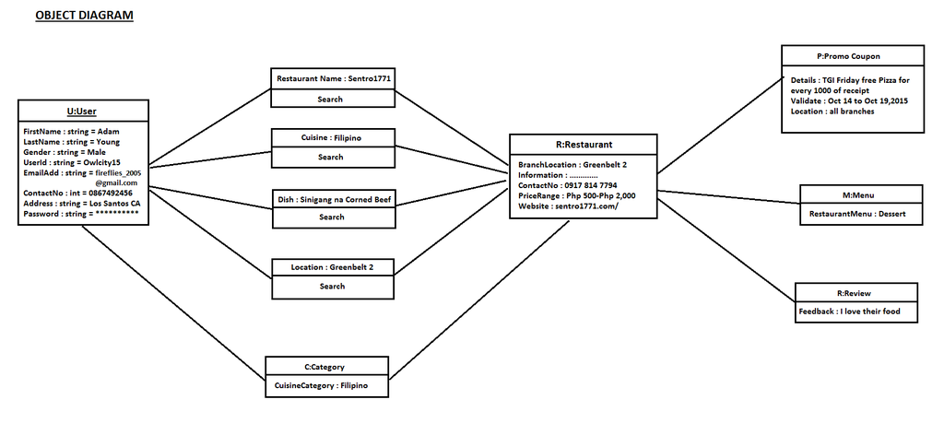

**ORIENTATION OVERVIEW DIAGRAM**

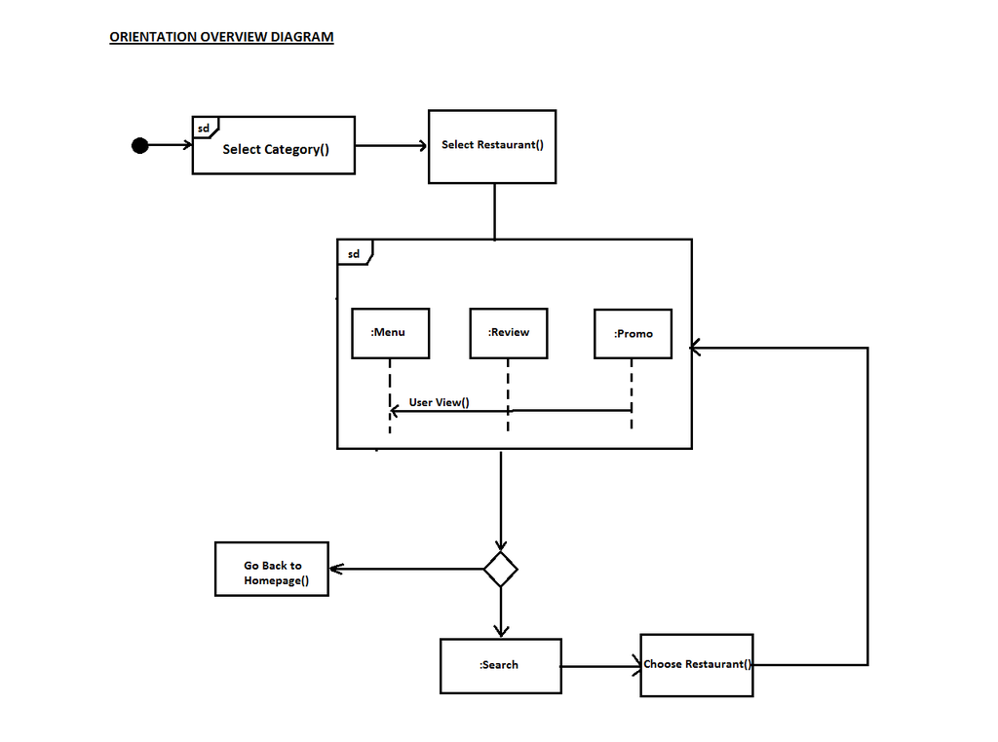

**Sequence Diagram**

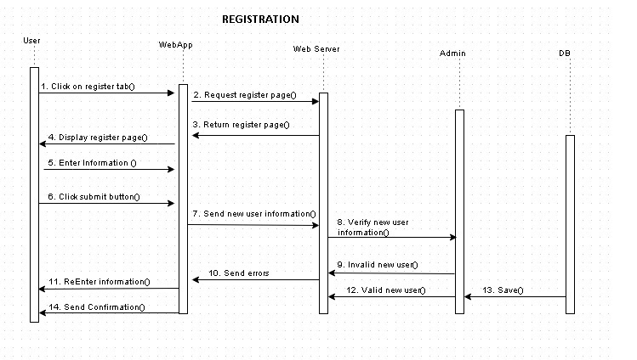

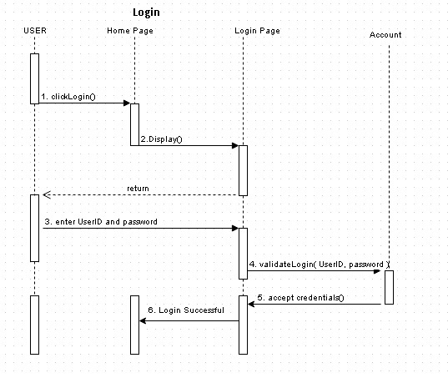

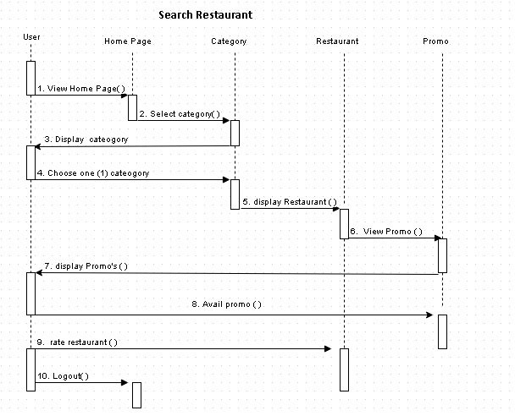

**Communication Diagram**

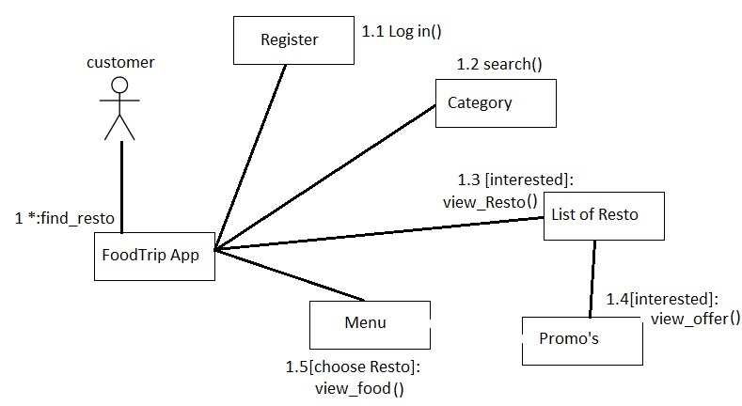

**Package Class Diagram**

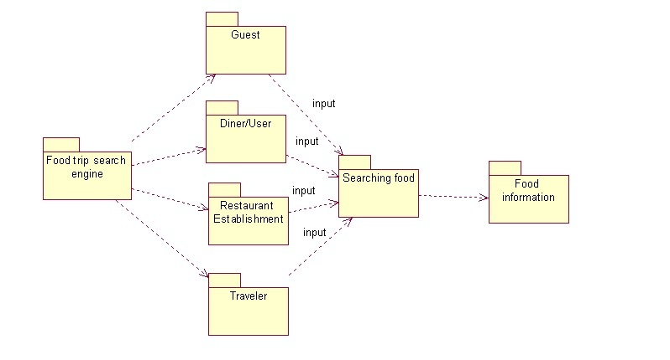

**Component Diagram**

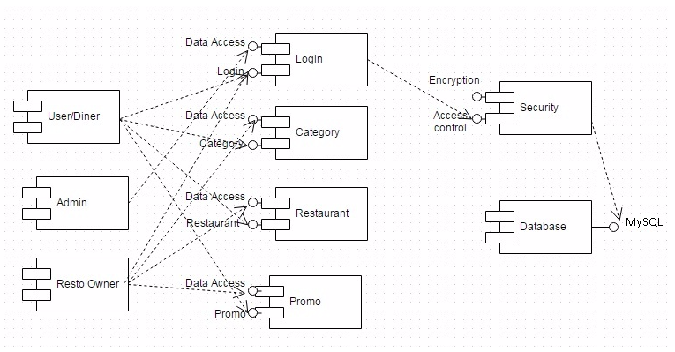

**Composite Diagram**

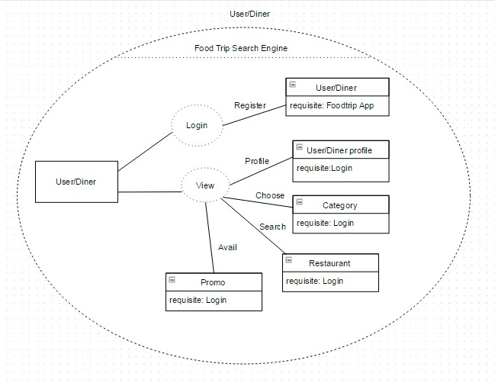

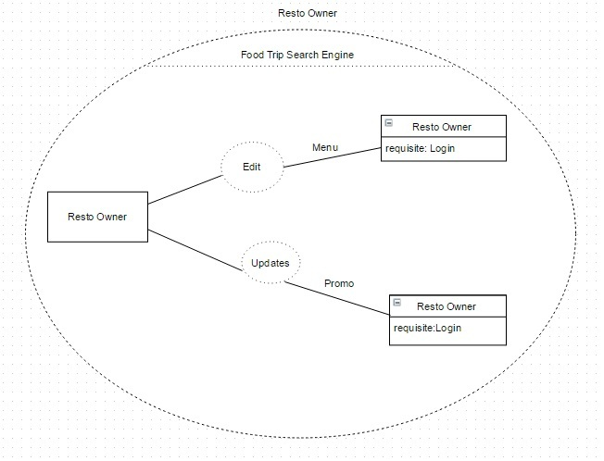

**Deployment Diagram**

